How to update software for your Q Station

There are 2 ways you can use to update software for your Q Station.

1. Auto upgrading
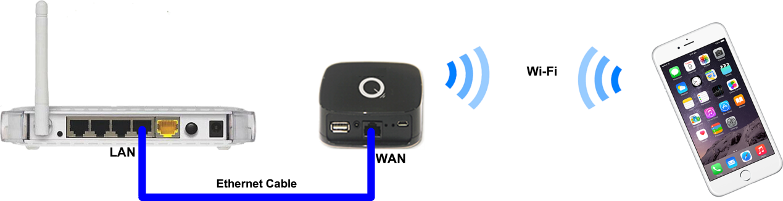
a. Use cable to connect your Q Station to your home router.
b. connect your laptop or iPhone to your Q station via wireless connection.
c. Use your IE, Chrome or any other Internet browsers to access 172.16.0.1.
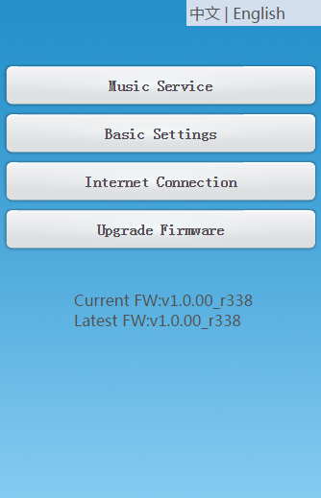
Then click 'Upgrade Firmware' -> 'Auto Upgrade Firmware' to update software.
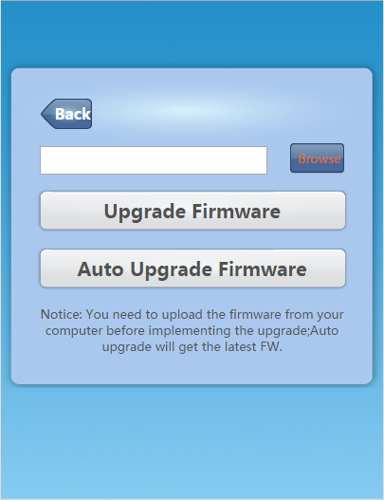
It will take few minutes on loading new software It's up to your Internet connection. When new software is loaded completely and then you'll be asked if you want to continue upgrading. Click ok to go ahead.

2. Manual upgrading
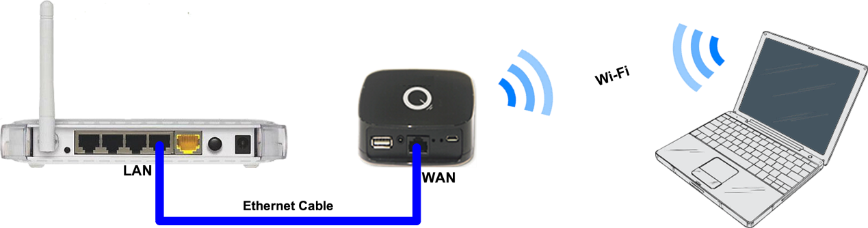
a. Download the latest software from http://www.belleds.com/en/firmware.html and keep it to your local disk.
b. Using your PC/laptop or other smart devices connect to the Wi-Fi connection of your Q Station directly.
c. Log in the web page of your Q Station by accessing http://172.16.0.1 with IE, Chrome or any other Internet browser.
d. Click 'Upgrade Firmware' and browser the software file from your local disk, then click Upgrade Firmware button.

e. When firmware file is loaded completely, you'll be asked if you want to continue the upgrading process. Click ok to go ahead. The upgrading process will take 1 or 2 minutes. Q Station will reboot automatically when it finish upgrading.

WARNING: Do not interrupt the power supply during upgrading, otherwise your device will become a brick.

